

**KAISAKA DATABASE APPLICATION**

Software Requirements Specification

| **Team Number** | 1 |
| --- | --- |
| **Section** | S16 |
| **Team Members** | Amon, Mikaela Nicole B.  Benigno, James Khalel C.  Campo, Roan Cedric V.  Chua, Gideon M.  Corpuz, Thara Mae P.  Dellosa, Mariella Jeanne A.  Helbling, John Patrick P.  Rivera, Paolo Eugene M.  Uy, Bea Antoinette C.  : |
| **Date Updated** | :: |

Aug 5, 2025

**Table of Contents**

**Executive Summary** **1**

**Overview of the Business Process** **2**

Existing Business Process 2

Data Requirements 3

Roles in the Business Process 4

**Problem Analysis** **7**

**Software Solution** **10**

Objectives 10

Characteristics 11

**Appendix A – Improved Business Process** **13**

**Appendix B – Sample Forms and Reports** **14**

**Appendix C – References and** **Acknowledgements 16**

# **Executive Summary**

Kaisahan ng Magulang at Anak na may Kapansanan, Inc. (KAISAKA) is a community-based, non-profit people’s organization that began in 1989 in Malate, Manila. It was initially an outreach program for individuals with disabilities, but over time, it evolved into a support group for mothers of children with disabilities. KAISAKA was officially registered with the Securities and Exchange Commission in August 1998, in recognition of the growing need for organized support.

KAISAKA currently operates in numerous barangays, including Leveriza, Adriatico, San Andres, Orosa, and Singgalong. Additionally, they collaborate with partner communities in Baseco and have outreach areas located in San Mateo. The organization estimates that, since its inception, it has supported more than 1,000 children with disabilities, and as of December 2024, it is actively caring for 151 children.

KAISAKA adopts a comprehensive rehabilitation strategy that focuses on the community. In addition to focusing on children, their services aim to empower families and communities through (1) Campaigns for raising awareness, (2) establishing partnerships, (3) developing capacity, and (4) Advocacy initiatives. They offer early intervention classes, physical therapy (at their center and via home visits), and training for parents on daily care. Special programs encompass livelihood training, where mothers create tote bags with the backing of institutions such as De La Salle University.

KAISAKA collaborates closely with several educational institutions, including Arellano University, Philippine Women’s University, St. De La Salle University, and Paul University. These collaborations make it easier to provide therapy services and community engagement initiatives, such as NSTP activities. The organization works with groups to supply assistive devices such as children’s wheelchairs.

As the children grow older, KAISAKA guarantees the children's ongoing development by providing leadership training and developmental assistance. Some of the individuals they support have had the chance to link up with global organizations like UNICEF.

To maintain efficiency and accountability, KAISAKA adheres to a structured system for evaluation and governance. Reports and assessments are conducted every three months, while a General Assembly is held and elections are conducted every two years.

In 2021, KAISAKA launched a website with the help of project-based funding. Since then, however, the organization has faced difficulties with access and usability because of insufficient training and proper documentation. At present, their urgent requirement is digital transformation—more specifically, the establishment and upkeep of an electronic database for improved management of beneficiary records and service monitoring.

# **Overview of the Business Process**

In Manila, KAISAKA Inc. is a community-based organization run by parents of disabled children. In addition to implementing rehabilitation programs, referrals, and community-building initiatives, its primary functions include registering, assisting, and monitoring recipient families. In order to provide services like physical therapy, early intervention programs, medical and educational referrals, assistive device procurement, and parent training, staff and volunteers collaborate closely with members, who are mostly mothers.

At the moment, physical folders, Excel spreadsheets, and written forms are used to manually handle all operational information, including kid profiles, family ties, service records, and attendance logs. Data collection, organization, and reporting are the responsibilities of staff members for both internal monitoring and external funding obligations. Participation in meetings, trainings, and year-round special events is another way the organization monitors member retention.

Although community engagement is at the heart of KAISAKA's initiatives, the lack of a centralized digital system has resulted in laborious procedures, redundant records, and challenges when it comes to creating reports. In order to better serve its expanding membership base and to expedite information access, document processing, and progress monitoring, the organization has realized the necessity of digitizing its operations.

The following are the organization's main business requirements:

* Accurately recording information about beneficiaries and caregivers
* Monitoring services offered and requested
* Tracking the involvement and status of the family
* Creating yearly and quarterly reports for interested parties
* Continuing to adhere to legal and administrative reporting requirements (BIR, SEC)

Only manual tools are now available to assist these operations, which leads to inefficiencies and lost possibilities for analysis and follow-up. These essential business procedures will be completely replaced and modernized by the planned digital solution, which will still be in line with KAISAKA's community-driven approach.

## **Existing Business Process**

The process begins when a caregiver (mother or family member of a disabled child) expresses their want to become a member of KAISAKA, they must provide physical documents, including a birth certificate, barangay certificate, doctor's certificate, and PWD ID. These are then thoroughly examined and placed in a folder designated for that family. Every disabled child is listed in paper files, with hand encoding of personal information such as age, kind of impairment, and educational placement. Excel files are occasionally kept on staff members' own devices, but they are not consolidated or standardized.

Staff members document activities in spreadsheets or paper records whenever KAISAKA provides services (such as therapy, help with school enrollment, or the supply of assistive devices). Sometimes tracking depends on verbal confirmation or memory since records are not updated instantly. Paper sign-in sheets are used to track attendance at activities. These are used by staff to identify families with active or retained members.

KAISAKA is required to produce reports for stakeholders and funders on a quarterly basis. Beneficiaries are counted according to their age group, gender, kind of impairment, educational background, and services received. Based on physical data, the staff manually determines ages from birthdates and creates statistics in Excel. Reporting frequently takes a few days. Different funders use different templates, necessitating repetitive reformatting of similar information.

Sometimes parents ask employees to verify if they have filed paperwork or gotten a certain service. Staff members must manually browse through folders because there is no system in place to keep track of these. On request, they will print a copy of the document if one is required. Facebook Messenger is the primary tool used for internal communication. Excel and Google Forms are only utilized in specific situations. Neither a content management system nor an integrated database are used by KAISAKA.

The business process can be visualized in the diagram shown in Figure 2-1.

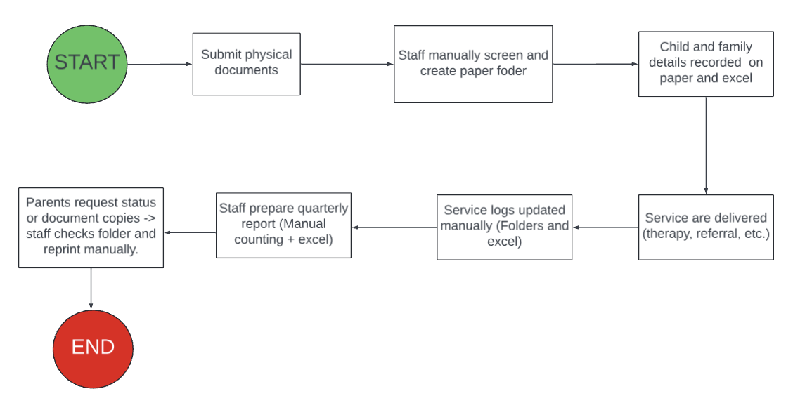

Figure 2-1. Existing Business Process

## **Data Requirements**

Paper-based registration forms are used by KAISAKA Inc. to collect necessary information for reporting and service delivery for both children and caregivers. However, we were not given access to hard copies of these forms because of the organization's present administrative practices and privacy concerns. Given the absence of formal authorization from the families concerned, the staff expressed concerns about sharing records that contain sensitive information. The data fields listed below, which represent what is presently gathered throughout the registration process, were therefore deduced from interviews, meetings, and system planning consultations with KAISAKA staff. The only available forms that KAISAKA provided are the List of Children and the Accomplishment Report, which are found in Appendix B and represent the kinds of data that are currently monitored for beneficiaries (see Figures B-1 and B-2).

The following required information is included in the KAISAKA child registration form: the child's full name, nickname, birthday, age, gender, home address, and handicap type. Additionally, it contains information on educational background, including the kind of school (private or public), current level (e.g., ALS, General Ed, or SPED), and school name. The date of registration, the child's membership status (active or inactive), and any supporting documentation (such as a birth certificate, PWD ID, or medical certificate) are all included in the child's record. In the database, every child is associated with a minimum of one caregiver.

The caregiver's full name, relationship to the child, gender, birthday, home address, phone number, and whether or not they are the primary guardian are all collected on the caregiver registration form. Their employment, civil status, and degree of participation in KAISAKA activities are also included.

The names of connected caregivers and children, as well as the barangay in which they reside, are all stored in a family record together with the unique family identification. This arrangement makes it easier for KAISAKA personnel to track interventions by organizing records under a single household.

Service type (e.g., therapy, eyeglasses, medical referral, assistive equipment, financial help), service date, and service status (requested, provided, pending) are all included in the services and interventions form. It is connected to the offending staff member and the kid. Each child may have many service logs from various time periods.

The name of the event or activity, the date, the participants (children and/or caregivers), and the attendance status are all listed on attendance forms. These forms, which are used to monitor member engagement and retention, are submitted following meetings, trainings, or outreach activities.

The pending verifications dashboard contains temporary records flagged for review by admin staff. Unverified registrations, missing paperwork, or ambiguous data submissions fall under this category. The record type, owner (employee or member), problem to be fixed, and present state are all included in each entry.

Reports are produced quarterly and annually using the kid, service, and attendance data that is currently available. The number of beneficiaries served by age group, gender, kind of disability, type of education, barangay of residence, and type of intervention received are all included in these reports. Every report has spreadsheet export options and complies with partner funders' data standards.

## **Roles in the Business Process**

Various employees are involved in the business process of ECTPA. The roles of these employees and their tasks are summarized in Table 2-1 and Table 2-2.

**Direct Services**

| **Role** | **Description of Tasks** |
| --- | --- |
| Program Head | * Oversees the execution and general operations of the program. * Oversees employees and guarantees the quality of services * Provides CBR and disability education to employees and members * Promotes children's rights by interacting with the community * Compiles reports for BOT and partners. |
| CBR Coordinator | * Manages daily community-based rehabilitation activities * Develops and administers community-based and home-based services * Oversees CBR employees * Coordinates with neighborhood partners, such as schools and health clinics. * Helps with reporting from partners |
| Para teacher/ Home Program Manager | * Develops and monitors home-based rehab programs * Manages Early Intervention Class * Coordinates referrals and service delivery with agencies * Monitors children’s progress and reports to partners |
| Social Worker / CO (part time) | * Evaluates incoming child beneficiaries' needs * Links families to resources (financial help, education, and treatment). * Helps families navigate societal structures * Collaborates with experts and safeguards resources |
| CBR Worker | * Helps with pre-vocational tasks, socializing, and treatment * Manages documentation, kid monitoring, and referrals * Represents KAISAKA in partner and community events. |
| Area worker (Baseco) | * Oversees the operations of the Baseco parent support group. * Keeps an eye on the beneficiaries who are children * Helps with therapy/support group sessions and referrals |
| Social Worker (part time, once a week, salary ℅ Sorok Uni) | * Oversees services and interns in physical therapy * Ensuring the community's therapy is of high quality * Educates and guides parents and CBR employees * Tracks the quality of PT services in field and clinic setting |

Table 2-1. Employee Roles and Tasks in KAISAKA’s Direct Services

**Administration, Documentation, and Reporting**

| **Role** | **Description of Tasks** |
| --- | --- |
| Program Head | * Oversees planning, budgeting, and implementation * Supervises staff and builds community partnerships * Ensures compliance and prepares required reports |
| CBR Coordinator | * Keeps accurate records of all services and activities * Helps with reporting and organizational documentation * Assists in obtaining supplies and resources |
| Bookkeeper | * Documents financial transactions and donations * Supports financial reporting and prepares bank reconciliations. |
| Treasurer | * Manages budget, oversees finances, and maintains records. * Helps with creating financial reports and disbursing monies. |
|  |  |

Table 2-2. Employee Roles and Tasks in KAISAKA’s Administration, Documentation, and Reporting

# **Problem Analysis**

This chapter presents the findings of the investigation into KAISAKA Inc.'s operational challenges, which the proposed software solution aims to address. KAISAKA Inc. is a community-based non-profit organization composed of parents and children with disabilities, empowering families and advocating for inclusive development. As their services and records grow, the requirement for digital support has grown critical.

| **#ID** | **Description** | **Cause** | **Symptoms** | **Impact** |
| --- | --- | --- | --- | --- |
|  | What’s the problem? | What causes the problem? | How do we know the problem exists? | Why is this important? What are the consequences? |
| 01 | Digital versions of the submitted documents are not available. | No uploading or digital filing feature for each beneficiary. | Everything is stored offline and cannot be retrieved remotely. | Lost documents and rework, inefficiencies when families relocate or request records. |
| 02 | There is no centralized, structured digital database. | Data is kept in physical files and scattered documents. | Difficulty finding child records and service histories | Increases worker effort, resulting in lost or outdated information |
| 03 | There is no role-based access restriction within the organization. | All records can be accessed and edited by anybody, regardless of responsibility. | Unauthorized access or unintentional alterations | Risks of data breaches and reporting inaccuracies. |
| 04 | Children's service histories are difficult to track. | No method for recording and linking delivered services to each beneficiary. | Staff cannot easily identify what each child has received or still needs. | Services are duplicated, and funders receive incomplete reports. |
| 05 | Parents often lose track of submitted documents. | They do not have access to any digital backups or downloaded copies. | Staff frequently searched physical files and reprinted documents. | Increases workload and delays children's access to services or benefits. |
| 06 | KAISAKA's previous website is inaccessible and cannot be maintained. | Lost credentials and contact information for the original developer. | The organization's web presence is down. | Missed outreach possibilities, no online visibility. |
| 07 | Staff and members are not trained to manage or maintain digital systems. | There was no previous onboarding or instructional support. | The abandonment of previous digital technologies (e.g., KAISAKA Websites) owing to confusion. | Loss of previous data systems. |
| 08 | Age data must be manually updated every reporting cycle. | No technique for automatically calculating age based on birthdate. | Every quarter, staff recalculate the ages and reclassify children. | Slows down data processing; prone to errors in age-based categorization. |
| 09 | Cannot easily search or group children using report filters. | Data is not organized into searchable tags or categories. | It takes time to identify children based on their age, disability, educational level, and other factors. | Slows down decision-making and report preparation. |
| 10 | Parents cannot input or modify their children's data. | No platform or interface allows members to add records. | All data encoding falls on the staff. | Risk of outdated or faulty information, increased staff workload. |
| 11 | Reports should be exported in funder-specific Excel formats. | Each funder has different reporting requirements. | Manual formatting of the same data for each partner | Report weariness, discrepancies, and delays |
| 12 | Quarterly reporting is tedious and time-consuming. | Reports are generated manually using spreadsheets and physical files. | Reporting can take up to three days; workers count age, gender, and services manually. | Wastes staff time, delays submissions, and increases the chance of human error. |
| 13 | Key staff need access to the system while working remotely. | There is no cloud-based solution | Admins cannot edit or verify data while traveling or outside the workplace. | Inconsistent oversight; delays in handling urgent matters. |
| 14 | Service requests (e.g., glasses, wheelchairs) are not recorded systematically. | No dedicated system to track pending or fulfilled needs | Requests are forgotten or duplicated. | Missed recommendations lead to extended wait times for beneficiaries. |
|  |  |  |  |  |

# **Software Solution**

In response to KAISAKA Inc.'s operational challenges, this chapter describes the proposed software solution for digitizing the organization's workflow. The KAISAKA Database Application is a web-based information system that streamlines data administration for beneficiaries, caregivers, services, and reporting. It replaces traditional documentation procedures with a secure, scalable, and user-friendly platform adapted to the organization's structure and requirements. This solution was built in close collaboration with KAISAKA's project head and is based on their real-world procedures, ensuring that the system directly supports daily operations and long-term goals. The following sections describe the system's objectives and non-functional qualities, which together define the basis for the proposed digital transformation.

## **Objectives**

The KAISAKA Database Application promises to provide a complete, cloud-based digital solution that addresses KAISAKA Inc.'s present operational inefficiencies. This system will allow the business to handle beneficiary data, service records, and reporting needs with increased accuracy, speed, and security as their operations are digitally transformed. It will also allow parents to participate in data ownership while preserving sensitive information via role-based access.

By eliminating manual processes and consolidating all critical information into a centralized, accessible platform, the system will directly address the organization's real challenges, such as time-consuming reporting, inconsistent records, limited access to digital documents, and a lack of structured data tracking mechanisms. The technology also intends to reduce staff load, limit human error, and facilitate remote administration, allowing KAISAKA to better serve its rising number of clients.

This effort demonstrates KAISAKA's ongoing commitment to providing inclusive, rights-based services for children with disabilities by developing internal processes that promote transparency, traceability, and timely reporting to stakeholders and partner organizations.

The software's precise aims are as follows:

* To provide a centralized database where staff can conveniently save, retrieve, and update beneficiary information.
* To automatically calculate beneficiaries' ages and classify them into relevant reporting groupings.
* To allow authorized KAISAKA staff to input and track services provided to each child.
* To allow selected members to submit or amend their own child's information via secure access.
* To enable the uploading and retrieval of digital documents such as medical certificates, birth certificates, and PWD IDs.
* To provide role-based access levels for employees, distinguishing between data encoders, administrators, and report creators.
* To allow advanced filtering and searching of beneficiary data based on age, gender, disability type, education cluster, and service history.
* To help generate and export quarterly reports in Excel formats matched with several funder templates;
* To create a secure, cloud-based solution that allows authorized users to access and control data remotely through desktop or mobile.
* To incorporate a basic interface for administrators to manage user accounts, system activities, and records.

## **Characteristics**

This section describes the non-functional requirements or system characteristics that will ensure the KAISAKA Database Application satisfies the practical demands of both staff and caregivers. These characteristics are required to create a system that is not only functional, but also sustainable, accessible, and empowering for the organization's operations and community-based objectives.

1. Clear and Consistent User Experience.

Given that KAISAKA employees and community members are the main users, the system must have a clean, uniform, and user-friendly interface. Navigation bars, list views, registration forms, and dashboards must adhere to consistent patterns.

* Visual hierarchy (logo placement and button prominence)
* Input formatting and feedback messages.
* Responsive design and iconography that correspond to local digital literacy levels

This ensures that users can use the system comfortably with minimum instruction

2. Real-time data responsiveness.

All views, including caregiver lists, child lists, pending verifications, activities, and dashboards, must display real-time, backend-connected data. Changes to the database (such as registrations, verifications, and intervention plans) should:

* Be immediately visible in the relevant interface.
* Load effectively using pagination or filtering.
* Require no manual refresh or page reload for updates.

This facilitates timely decision-making and effective case tracking.

3. Structured Relationships and Data Integrity

Since the system tracks relationships among caregivers, children, activities, and services:

* Backend logic must guarantee clean relational mapping (e.g., one caregiver for numerous children).
* List displays and dashboards should clearly reflect these linkages.
* Registration forms must eliminate data duplication and enable real-time linking to existing family records.

This preserves the database's integrity while simplifying verification operations.

4. Scalability & Performance

As more kids, caregivers, and activities are recorded, the system must remain responsive and reliable. Specifically:

* Dashboards should collect real-time facts without lag.
* Backend queries must be optimized for finding and filtering by many attributes, such as handicap kind and intervention status.

This ensures long-term viability as KAISAKA expands.

5. Maintenance and Documentation

The system should be simple for KAISAKA or future developers to update. To support this:

* Source code should adhere to uniform patterns and naming standards.
* Documentation should include deployment instructions, database schema references, and administrative usage manuals.
* Testing infrastructure (e.g., unit tests and scripts) should facilitate future verification.

This makes the system more future-proof and allows for long-term maintenance without relying on external resources.

# **Appendix A – Improved Business Process**

The organization's operations will be converted from a manually updated, paper-based system to a centralized digital platform that facilitates role-based access, secure document storage, real-time data entry, and automated report generation upon the implementation of the KAISAKA Information Management Web Application. By preventing data loss and empowering caregivers to participate in the information management process, the enhanced procedure lessens the workload of KAISAKA staff.

After receiving staff approval, the caregiver may enter their child's data and digital copies of the necessary paperwork straight into the system. Using a pending verification dashboard, staff will examine, confirm, and approve the information that has been provided. Once verified, the child and family information is stored in the system and linked automatically.

The designated staff enter all services, such as therapy sessions, referrals, or assistance with assistive devices, directly into the system. The service history for every child is updated instantly. System-based forms are used to digitally record event attendance, which is then used to track member retention.

Manual preparation of reports is no longer necessary. With a few clicks, KAISAKA employees may create quarterly and yearly reports by applying filters for education classification, age, gender, and handicap type. Children's ages are automatically determined by the algorithm, which then groups them appropriately.

Staff may now safely print or access data without handling physical folders, and parents can obtain digital versions of the papers they have supplied as needed. The dashboard of the system provides a summary of important data, including the number of children with intervention plans, completed services, and active beneficiaries. Employees may manage data and run reports from home or overseas thanks to the enhanced process's remote access capabilities. Only authorized personnel may see or alter sensitive data thanks to the system's adaptation to user roles.

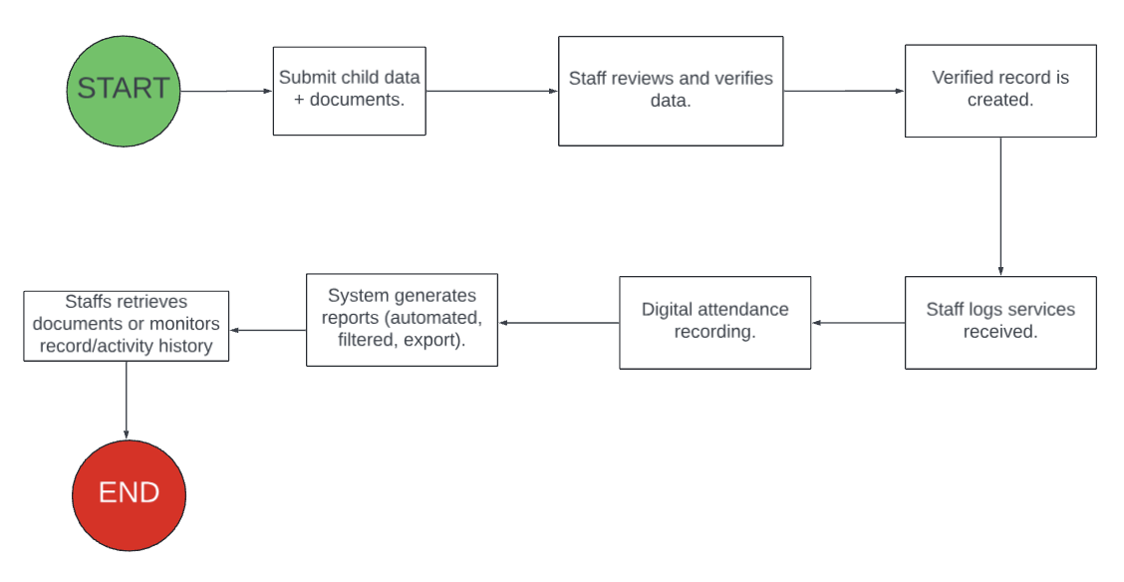

Figure A-1. Improved Business Process

# **Appendix B – Sample Forms and Reports**

This appendix includes the sample forms and reports used by KAISAKA Inc. as part of their current manual business processes. These forms facilitate internal beneficiary monitoring, report preparation, and service tracking. However, only selected templates have been provided by the organization for documentation purposes due to confidentiality restrictions.

*B-1. Accomplishment report template*

KAISAKA tracks the services provided to beneficiaries during a certain time period using the Accomplishment Report. The number of participants or beneficiaries served, the type of service or activity, the date of completion, and the accountable staff person are all included. The quarterly and yearly reporting responsibilities to funders and stakeholders are supported by this report.

For the sample template, see Figure B-1.

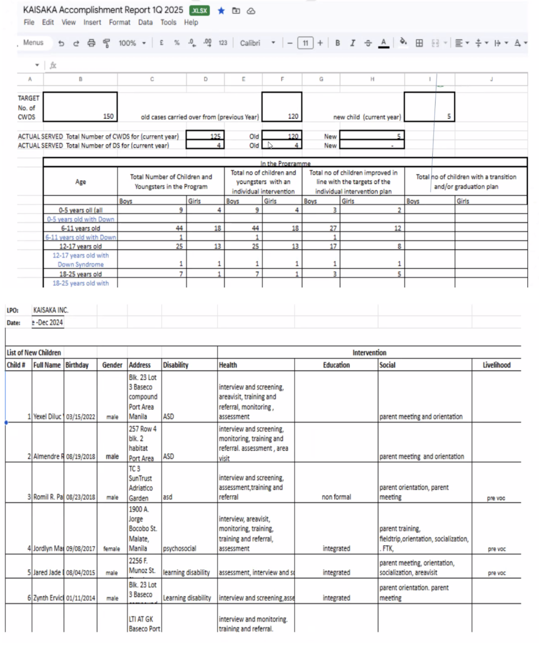

*Figure B-1. Accomplishment Report*

*B-2. List of children template*

A list of all registered child beneficiaries, including with their personal and educational details, may be found in the List of Children report. Fields including complete name, age, gender, kind of disability and address are usually included. Reporting, service planning, and record verification are all supported by this list.

The sample report is shown in Figure B-2.

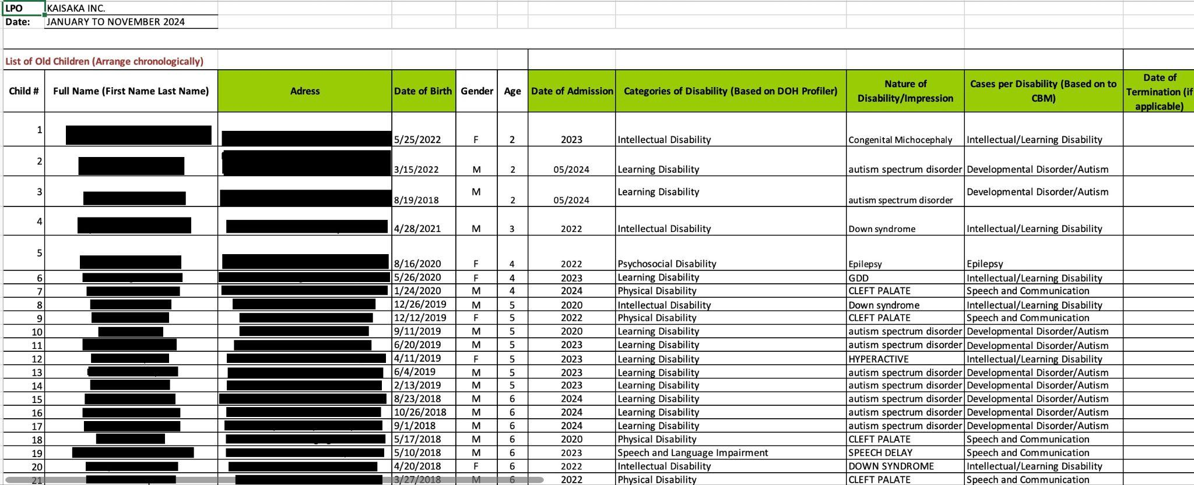

*Figure B-2. List of Children Template*

# **Appendix C – References and Acknowledgement**

The team used a selection of digital tools and platforms to support the design, development, and deployment of the system during the project. Jira was utilized for efficient team task coordination, sprint organization, and user story management. Building interactive prototypes and developing the user experience were done collaboratively using Figma. The backend service for database structure, user authentication, and real-time data processing was Supabase. Vercel was used to deploy the application in order to provide continuous integration and smooth testing.

No printed books or journal articles were referenced in this project. The definitions of data fields, domain-specific information, and business process insights were all taken straight from KAISAKA's internal documentation and team meetings. A contextual basis for understanding the organization's fundamental programs, procedures, and community-based approach was also provided by the KAISAKA Manual of Operations (2023).

Our team would like to sincerely thank Miss Jeannifer B. Villanueva, KAISAKA Inc.'s Program Head, for her enthusiastic participation and steadfast support during the project. The team was able to completely comprehend the demands of the company because of her diligence, clarity, and regular communication. She gave insightful input at every planning step and clearly described the particular operational issues KAISAKA was facing. Under her direction, the proposed solution was guaranteed to be in line with the organization's objectives and the realities of the communities they serve.